Software Requirements Specification (SRS)

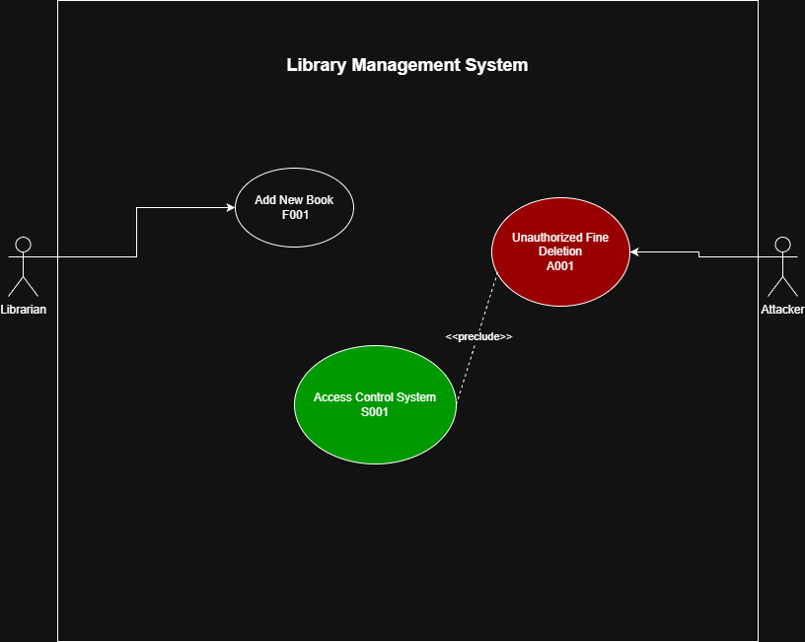

Figure 1: Use Case Diagram for Library Management System
Project Title: Library Management System (Secure Desktop Application)
Course: Lab 04 - Security Requirements

Team Members & Roles:
- Khalid Almohannadi: Lead Functional Analyst (Responsible for Functional Use Cases).
- Awad Hamad: Security Threat Analyst (Responsible for Abuse Cases).
- Saif Alkorbi: Security Engineer (Responsible for Security Use Cases).

1. Functional Requirements (F)
Prepared by: Khalid Almohannadi

Use Case Card: F001
Field | Description
Use case Id | F001
Name | Add New Book
Created By/Author | Khalid Almohannadi
Date Created | 11 Feb 2026
Actor | Librarian
Description/Summary | The system shall allow the Librarian to add a new book to the library catalog by entering details like Title, Author, and ISBN so that it becomes available for borrowing.
Preconditions | 1. The Librarian is successfully logged into the system.  2. The book's ISBN is not already registered.
Postconditions | The book record is saved in the database and updated in the catalog.
Normal course of events | 1. Librarian opens "Add Book" interface.  2. Librarian enters Title, Author, and ISBN.  3. Librarian clicks "Save".  4. System validates data and confirms success.
Exceptions | 1. Duplicate ISBN: System displays error.  2. Missing mandatory fields: System prompts for data.
Acceptance Criteria | The new book is searchable in the library catalog and displays the correct details.

2. Abuse Cases (A)
Prepared by: Awad Hamad

Abuse Case Card: A001
Field | Description
Abuse case Id | A001
Name | Unauthorized Fine Deletion
Created By/Author | Awad Hamad
Date | 11 Feb 2026
Priority | High
Scope | Database Integrity / Financial Records
Mis-actors | Malicious Member or Unauthorized Staff
Access Right Levels | Low Level System User
Point of Entry | Database connection or Member Profile Page
Security Attributes Affected | Integrity (Financial data alteration)
Description | An attacker attempts to bypass the payment gateway or gain access to the database to set their overdue fines to zero without actual payment.
Sophistication | Medium
Postconditions | Financial records are tampered with, causing revenue loss.
Related Use Cases | F003 (Return Books & Manage Fines)
Acceptance Criteria | The attacker successfully modifies the fine value in the database.

3. Security Use Cases (S)
Prepared by: Saif Alkorbi

Security Use Case Card: S001
Field | Description
Use case Id | S001
Name | Implement Role-Based Access Control (RBAC)
Created By/Author | Saif Alkorbi
Date Created | 11 Feb 2026
Actor | The System
Description/Summary | The system must enforce strict access control where only authorized "Admins" can modify or delete fine records to mitigate A001.
Preconditions | User attempts to access a restricted financial function.
Postconditions | Unauthorized access is blocked and logged.
Normal course of events | 1. User requests to modify a fine.  2. System checks user's role.  3. If "Admin", access is granted.  4. If "Member", access is denied.
Exceptions | System failure to retrieve user role (Default to Deny).
Acceptance Criteria | A user with "Member" privileges cannot change any numeric value in the fine field.

